About Home directory in Jenkins

A filesystem will create once Jenkins is Installed in our machine

If we install Jenkins in Ubuntu machine below is the default path

/var/lib/Jenkins>



All below files are related to Jenkins which are exist under Jenkins folder

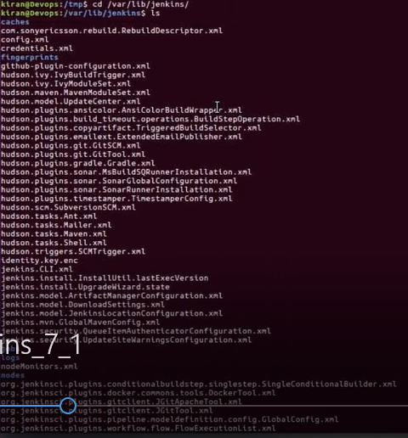

Now we are going to create on Directory with Name Jenkins Home /var/Jenkins Home

And we will move total content of **Jenkins in to JenkinsHome**

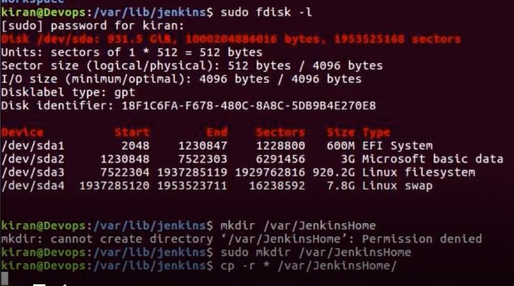

Default path config setting available in ManageJenkins>config >Home directory

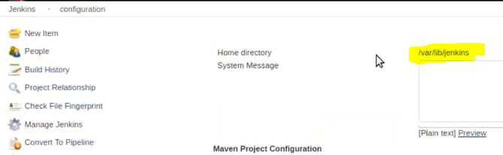

For example if you want to check the permission for particular directory use below command

ls-ld /var/JenkinsHome

so it will display the permission of JenkinsHome



If you give ls –l so it will display all the permissions of the data which is exist under that directory

**Log Rotation:**

Whenever a Job is execute a new version(build) will be created multiple builds will available , here we can set limitation that last 2days or last 10 jobs should available remaining jobs can delete like that .

To set that configuration Move to that Job and config

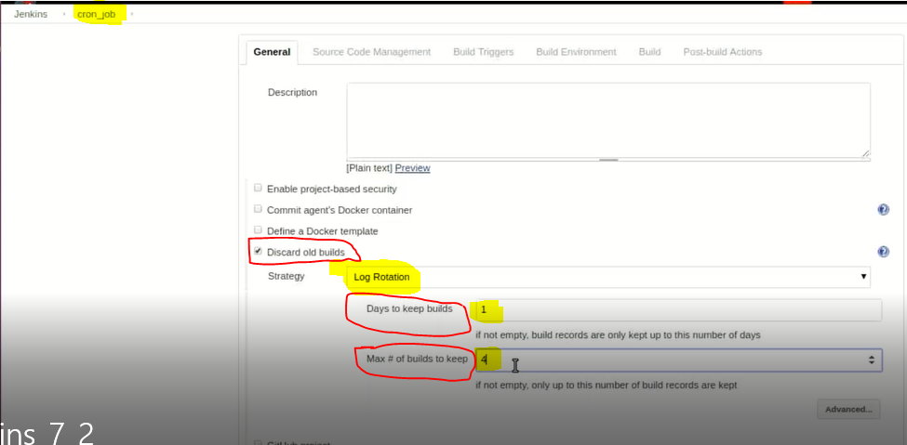

In Jenkins we can create User and we can provide Permission to that user

ManageJenkins>Manage users>create New user

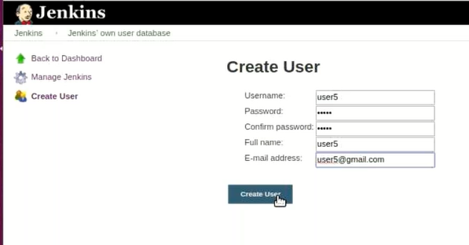

Once user is created then we will set permission level by following below process

ManageJenkins>Configure Global Security

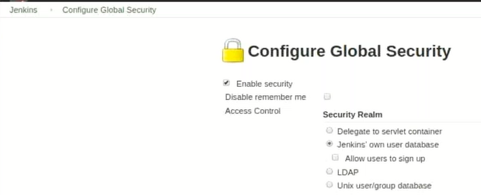

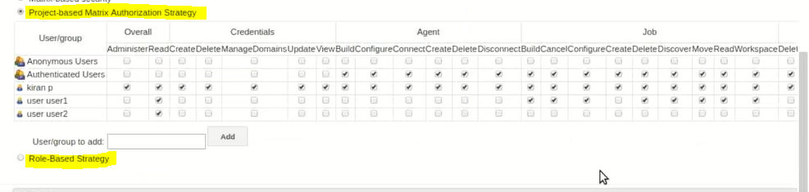

We can create Role base as well , here we will create some Roles and set some permissions and then we will assign users to that Roles